**Cost management and cost-saving**

1. Aws resource explorer
2. AWS tag editor

**AWS resource explorer**

AWS resource explorer: It is an AWS service that helps us to find/search different resources that are present in different regions

To use AWS resource explorer, we have to first enable it

**Benefits:**

* It is free to use
* We can search directly from the search bar
* We can view all the resources in our AWS account even if they are present in different regions
* We can quickly search with different filters in your query

There are two options which we can select:

1. Quick set-up:
2. Advance set-up

In advance setup, we can customize the aggregator index 🡪 if we want to replicate resources from all AWS regions or not

We can also select if we want to select the default view or not

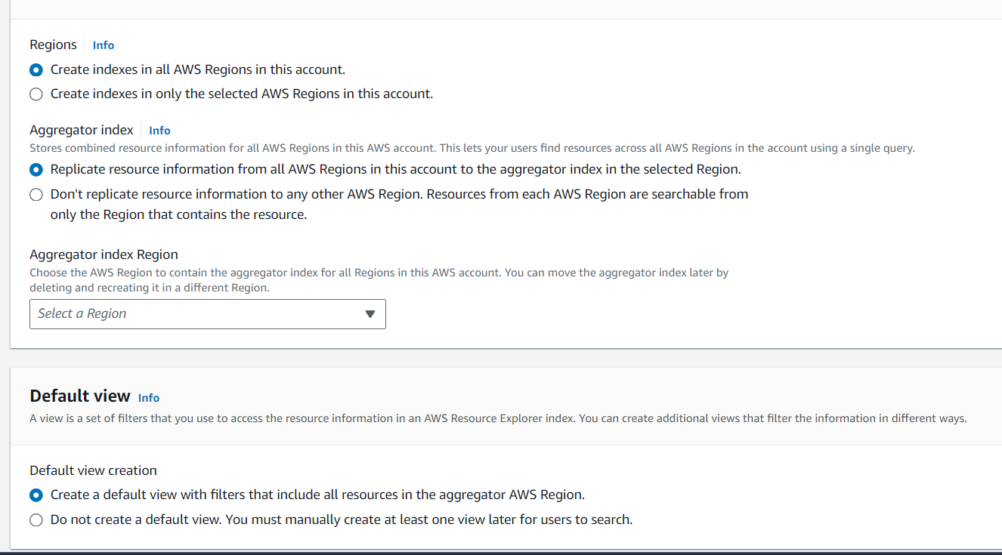

We can search using Query:

Filters:

* Id 🡪 arn:aws:s3::bucket_name
* Account id 🡪 124345
* Regions 🡪 us-east-1
* Service 🡪 EC2
* Tag
* Resource type 🡪 ec2:instance

Operations:

* * - wildcard (string*)
* “ - ” exclude from search
* “ \ ” literal characters

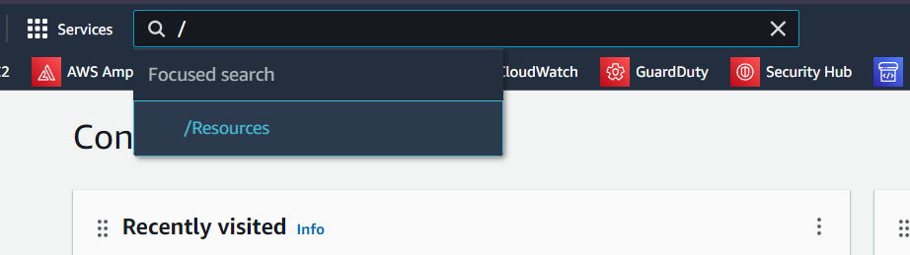

To access resources we have to write /resources and then write the service name for which we want to view the resources

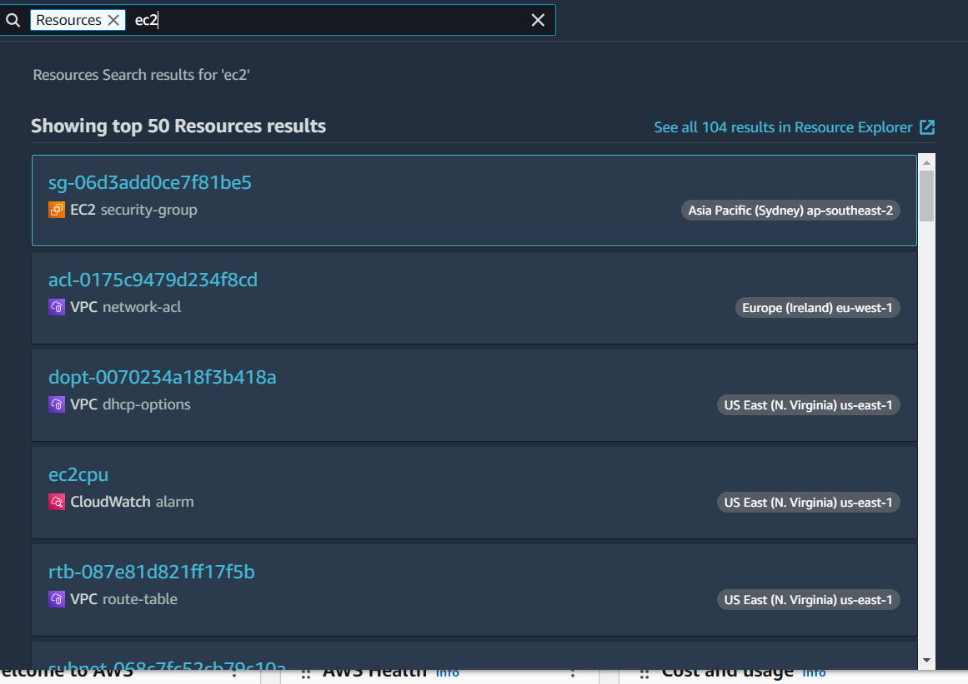

In the view tab, we can make our view by applying filters

The view tab is basically used for the search bar

**Tag editor**

* In the tag editor, we can select selective regions/one region/all regions
* The same goes for resource type we can select multiple service resources
* We can even add a specific tag to find the resource

